Гумметов Рустам Алиевич, Б18-191-2

№1

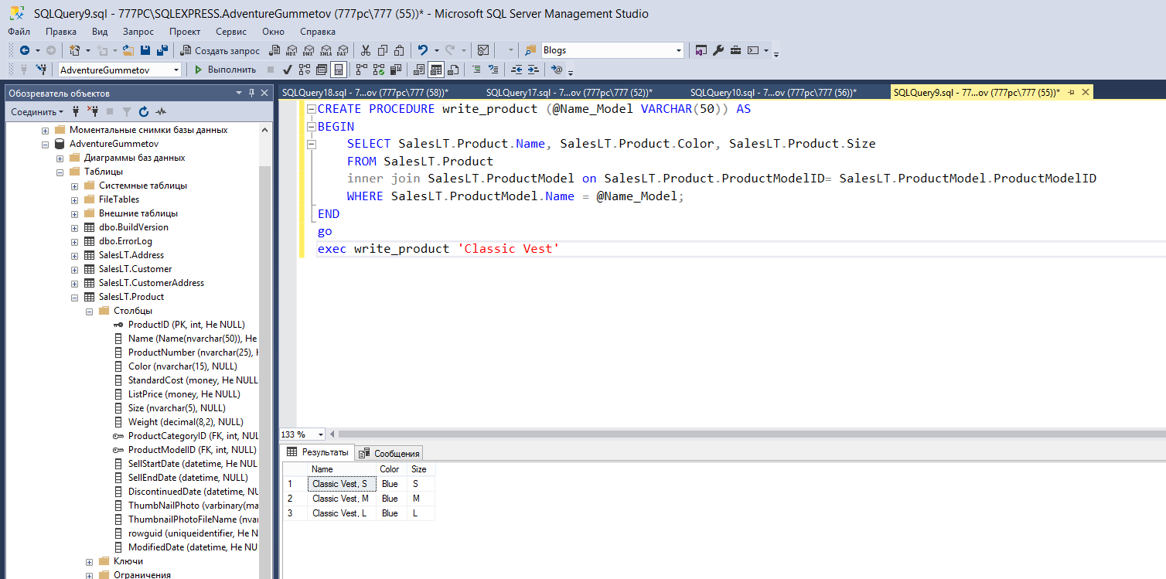

Рис. 1

CREATE PROCEDURE write_product (@Name_Model VARCHAR(50)) AS

BEGIN

SELECT SalesLT.Product.Name, SalesLT.Product.Color, SalesLT.Product.Size

FROM SalesLT.Product

inner join SalesLT.ProductModel on SalesLT.Product.ProductModelID= SalesLT.ProductModel.ProductModelID

WHERE SalesLT.ProductModel.Name = @Name_Model;

END

go

exec write_product 'Classic Vest'

№2

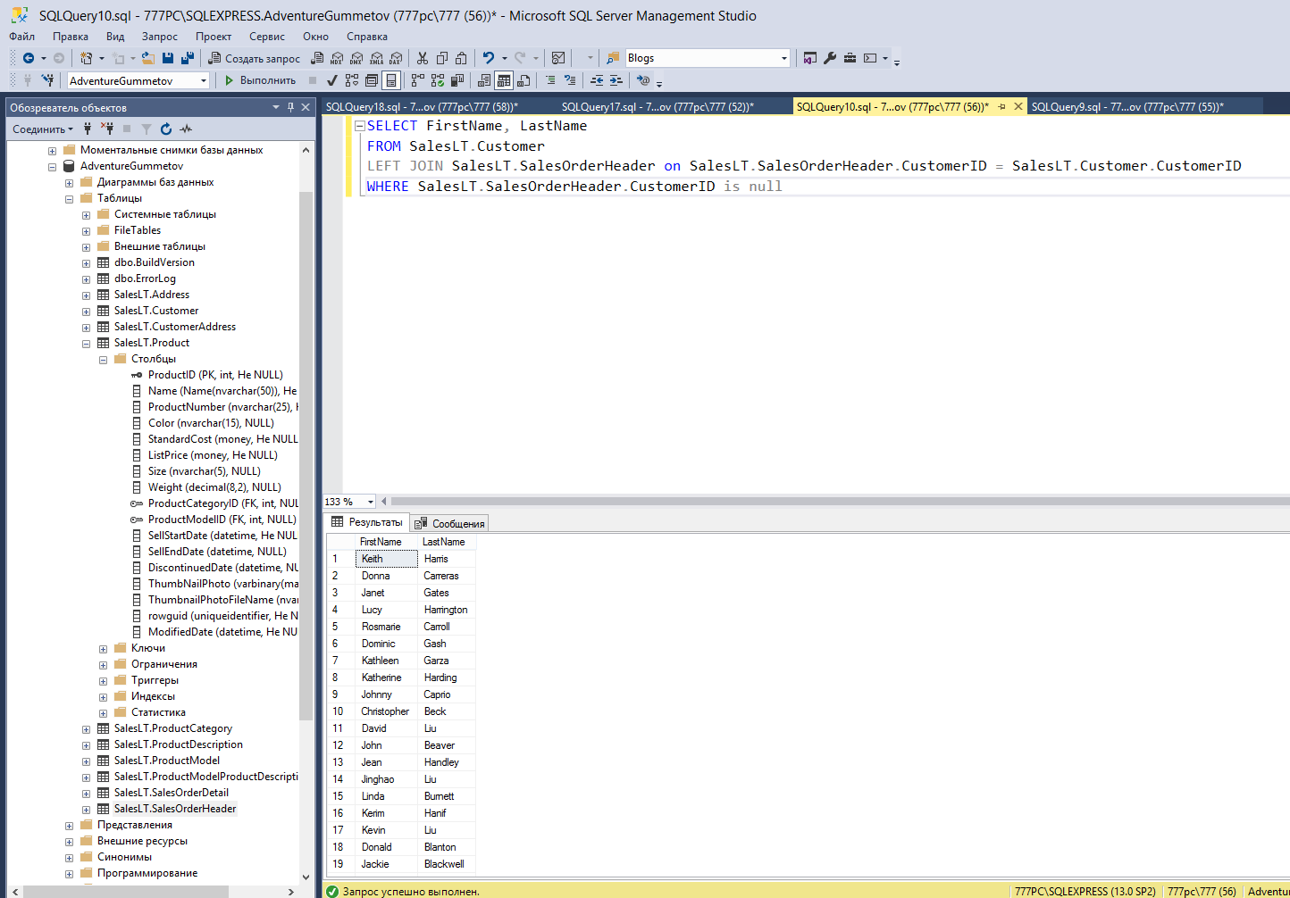

Рис. 2

SELECT FirstName, LastName

FROM SalesLT.Customer

LEFT JOIN SalesLT.SalesOrderHeader on SalesLT.SalesOrderHeader.CustomerID = SalesLT.Customer.CustomerID

WHERE SalesLT.SalesOrderHeader.CustomerID is null

№3

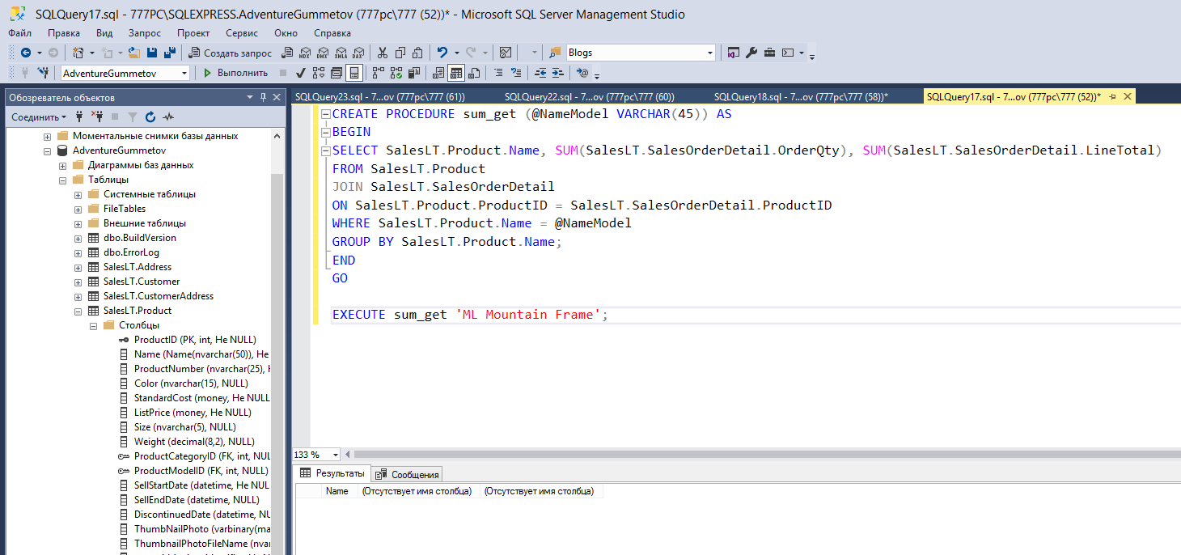

Рис. 3

CREATE PROCEDURE sum_get (@NameModel VARCHAR(45)) AS

BEGIN

SELECT SalesLT.Product.Name, SUM(SalesLT.SalesOrderDetail.OrderQty), SUM(SalesLT.SalesOrderDetail.LineTotal)

FROM SalesLT.Product

JOIN SalesLT.SalesOrderDetail

ON SalesLT.Product.ProductID = SalesLT.SalesOrderDetail.ProductID

WHERE SalesLT.Product.Name = @NameModel

GROUP BY SalesLT.Product.Name;

END

GO

EXECUTE sum_get 'ML Mountain Frame';

№4

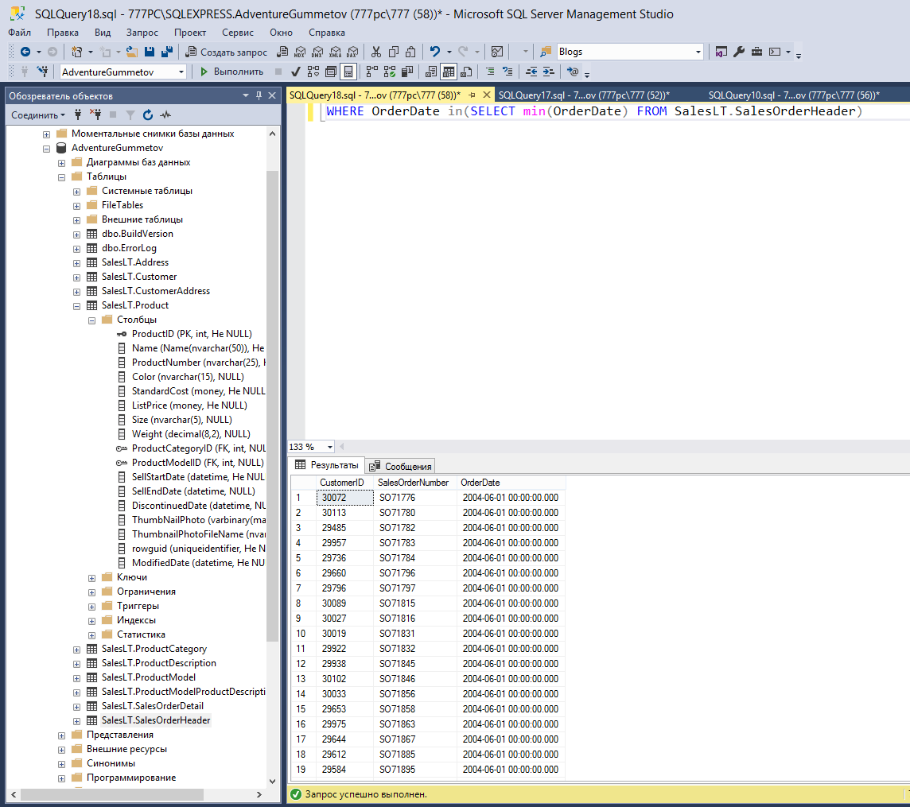

Рис. 4

WHERE OrderDate in(SELECT min(OrderDate) FROM SalesLT.SalesOrderHeader)